Plugging Into The Future: An Exploration of Electricity Consumption Patterns using Tableau

**PROJECT REPORT**

**Executive Summary**

This project investigates electricity consumption patterns across various regions, sectors, and timeframes using **Tableau** as the primary visualization tool. The goal is to identify trends, anomalies, and potential opportunities for optimization in electricity usage. By leveraging interactive dashboards, stakeholders can make data-driven decisions to support sustainability, infrastructure planning, and energy policy development.

**Project Objectives**

* To visualize historical electricity consumption data.
* To identify trends by region, season, and sector.
* To compare consumption between residential, commercial, and industrial users.
* To highlight peak consumption periods and potential inefficiencies.
* To provide insights and recommendations for energy management.

**Visualizations and Dashboards**

**1. Electricity Consumption Over Time**

* **Chart Type:** Line chart
* **Insights:** Seasonal spikes, yearly trends, peak consumption years

**2. Consumption by Region**

* **Chart Type:** Map + bar chart
* **Insights:** Which regions consume the most electricity? Urban vs rural comparison

**3. Sector-Wise Usage**

* **Chart Type:** Stacked bar chart
* **Insights:** Dominant sectors contributing to energy demand

**4. Hourly/Daily Patterns**

* **Chart Type:** Heatmap or area chart
* **Insights:** Peak hours and energy load curves

**5. Cost vs Consumption**

* **Chart Type:** Scatter plot
* **Insights:** Are higher consumption areas paying more per kWh?

**Key Insights**

* **Trend Analysis:** A steady rise in electricity demand over the past 10 years, especially in urban areas.
* **Sectoral Insight:** The commercial sector has overtaken industrial in certain states due to increased digitalization.
* **Geographical Insight:** Northern and coastal regions exhibit higher residential consumption, possibly due to heating/cooling demands.
* **Efficiency Insight:** Some regions with high consumption show disproportionately low cost, indicating potential subsidies or inefficiencies.

**Appendix**

Include:

* Screenshots of key Tableau dashboards
* Data dictionary
* Source links

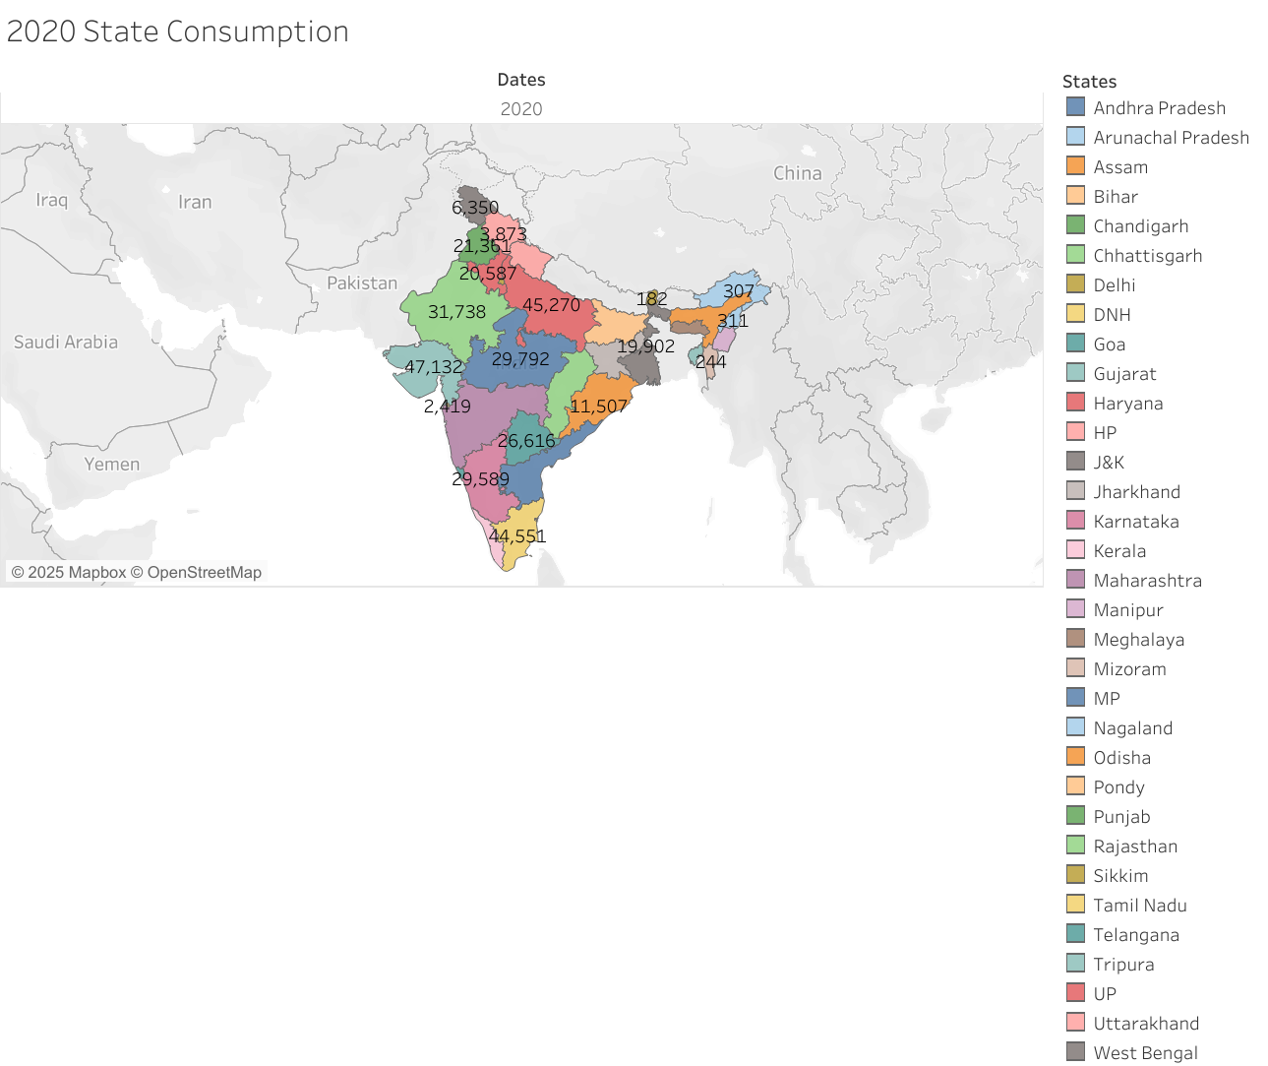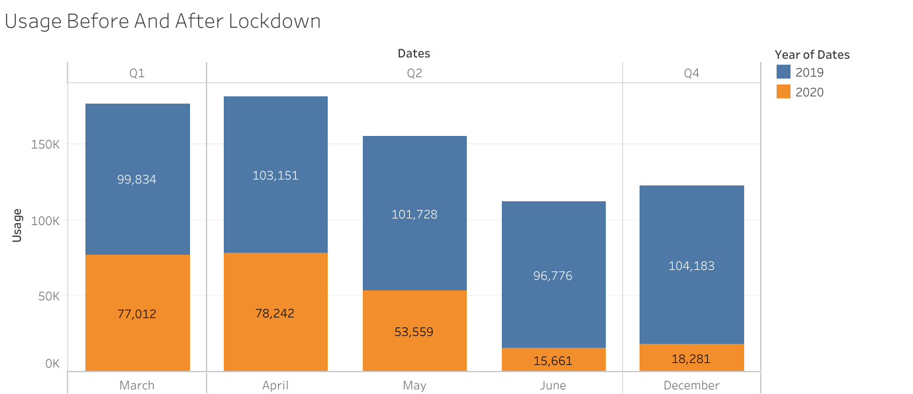**Result**

